What is the ROC Curve?
The ROC curve gives a visual representation of the trade-offs between the true positive rate (TPR) and false positive rate (FPR) at various thresholds. It provides insights into how well the model can balance the trade-offs between detecting positive instances and avoiding false positives across different thresholds. AUC, or Area Under the Curve, is a single scalar value ranging from 0 to 1, that gives a performance snapshot of the model. You only calculate AUC after generating the ROC curve because the AUC represents the area beneath the curve.

True positive rate
The true positive rate, also known as sensitivity or recall, reflects a model’s ability to correctly identify positive instances. It measures the proportion of actual positive cases that the model successfully identifies. Mathematically, this can be expressed by the following equation:
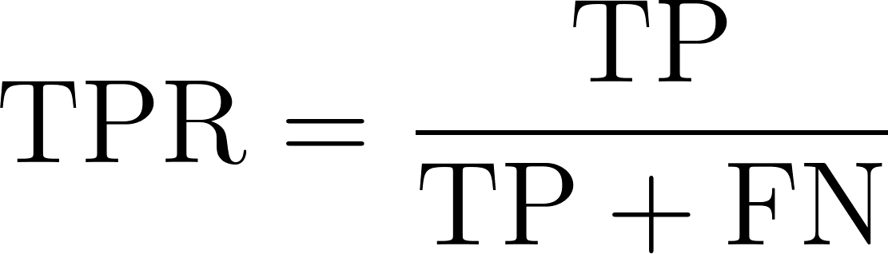

Where:
- TP or true positives are the number of positive class records the model correctly predicts as positive.
- FN or false negatives are the number of positive class records the model incorrectly predicts as negative.

False positive rate
FPR represents how often our model incorrectly classifies negative class instances as positive. It measures the proportion of actual negative instances that are incorrectly identified as positive by the model, indicating the rate of false alarms. Mathematical this can be expressed as follows.

Where:
- FP or false positives are the number of negative class records that are incorrectly predicted as positive.
- TN or true negatives are the number of negative class records that are correctly predicted as negative.
Image-
https://github.com/adas754/ML_Foundations/blob/main/0_VmdsukltMmSfn1iK.webp

Why use the AUC-ROC curve?
Let’s understand scenarios where AUC-ROC is a more relevant metric.

Measuring performance
AUC-ROC provides an aggregate performance measure across all possible classification thresholds. Unlike accuracy, precision, or F1-score that depend on a specific threshold, it considers the model performance at different operating points.

Model comparison
AUC-ROC is a single scalar value that makes it easier to compare multiple models, regardless of their classification thresholds. Its threshold-independent nature makes it a better choice to draw a fair comparison between models with different optimal thresholds.

Looking at class imbalance
Most real-life datasets are imbalanced where one class is disproportionately more than the other, for example, sentiment analysis, fraud detection, and cancer detection. In such scenarios, metrics like accuracy provide a misleading assessment of model performance as they are biased toward the majority class. In such scenarios, metrics like AUC-ROC are more reliable.

How to Read and Understand the AUC-ROC Curve
Let's break down the metrics the AUC-ROC curve provides and understand their significance.

Interpreting the AUC value
AUC values provide a quick reference to understand how well the model is performing. When AUC is close to 1, our model is at the top of its game. It shows excellent performance with a strong ability to distinguish between classes. AUC around 0.5 is a concerning scenario, as it highlights that the model isn’t doing any better than random guessing, signaling no discriminatory power. An AUC score closer to 0 is an alarming situation. This indicates the model is getting it entirely wrong, even worse than a coin toss.

True positive rate: measuring success
TPR, or sensitivity, is a critical metric that tells how well our model is capturing the positive instances. TPR is calculated as the proportion of actual positives correctly identified by the model. It’s a key indicator of our model’s effectiveness in detecting the true signals (positives). High TPR means our model is doing a great job of recognizing what matters most.

False positive rate: gauging the noise
On the flip side, FPR helps us understand the noise—how often our model falsely identifies negatives as positives. FPR is the proportion of actual negatives that our model incorrectly flags as positives. It’s a vital metric for assessing the trade-offs our model is making. A high FPR indicates a tendency to produce false alarms, which can be costly depending on the application.

Balancing sensitivity and specificity
The beauty and the challenge of binary classification lie in the threshold settings and therefore we fine-tune our model's sensitivity (TPR) and specificity (1 - FPR). We can control how sensitive our model is to detecting positive class instances and reduce false positives by tuning the threshold. In most real-world scenarios, the cost of false negatives (missing a positive) versus false positives (false alarms) can vary significantly.

Real-World Use Cases of the AUC-ROC Curve
AUC-ROC isn’t just a theoretical concept; here is how this practical metric is used across industries to drive critical decisions:

Medical diagnostics
AUC-ROC is used to compare different diagnostic tests. It is especially useful when the cost of false negatives (for example, missing a disease) can be much more than false positives (for example, unnecessary treatment). A noteworthy example would be cancer screening, where the threshold for further testing can be adjusted based on risk factors and resource availability.

Fraud detection
Machine learning models are increasingly used to identify fraudulent activities in the financial sector. Considering that fraud transactions are significantly rare, such datasets are highly imbalanced. Therefore, AUC-ROC is an effective evaluation metric that also allows for adjusting the threshold based on various factors, such as the magnitude of the risk involved with the transaction, the cost of manually verifying each transaction and the cost of customer inconvenience.

Cybersecurity
Similar to fraud detection, cyber-attacks are also relatively rare events. Hence, AUC-ROC also finds application in cybersecurity, balancing between detecting threats and avoiding alert fatigue from false positives.

Alternatives to the AUC-ROC Curve
AUC-ROC is a popular metric for evaluating binary classification models, but there are scenarios where alternative metrics may be more suitable. Let's explore some alternatives and when to use them:

Precision-recall curve
The precision-recall curve (PRC) is a metric for imbalanced datasets that significantly impacts the value of the machine learning model when false positives and false negatives have different costs. Unlike AUC-ROC, which can give a misleadingly optimistic view in imbalanced datasets, PRC focuses more on performance concerning the positive class.

F1 score
The F1 score is the harmonic mean of precision and recall, providing a single metric that balances both. It's used when we need a clear, single-number summary of model performance especially in imbalanced datasets. AUC-ROC provides a more global view, while F1 is a specific point on the PRC curve.

Conclusion
AUC-ROC is a gold standard in binary classification problems because it provides a more balanced view of how well the model performs across different thresholds, especially in class-imbalance scenarios.

